**A PROJECT REPORT ON**

**“E-PLANT SOLUTIONS”**

By

Patanjali Pandey

Reg. No. – 18111060012

Session – 2018-21

Roll. No. 18CS012

Under the guidance of

**Mr. Sayan Kundu**

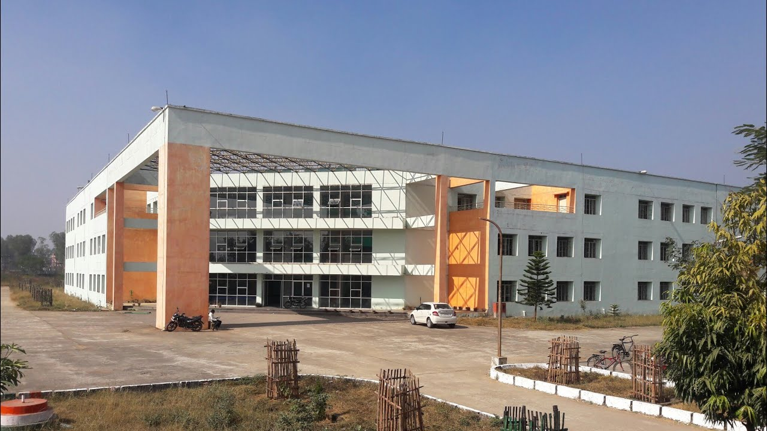

SUBMITTED IN PARTIAL FULFILMENT OF THE REQUIREMENTS FOR THE DEGREE OF DIPLOMA

**SILLI POLYTECHNIC SILLI**

SILLI (JHARKHAND)834002, INDIA JUNE 2019

**SILLI POLYTECHNIC SILLI**

SILLI (JHARKHAND), INDIA



**FORWORD**

We hereby forward the thesis report entitled “**E-PLANT SOLUTIONS**” presented by **PATANJALI PANDEY**, 6th semester diploma,session 2016-2019,under guidance in **MR.SAYAN KUNDU** (Assistant professor at **SILLI POLYTECHNIC**).

Dated:

Countersigned ,HOD

**ACKNOWLEDGEMENT**

Firstly,we must thank the almighty god who gave us good main to work on the project. Expressing grattitude is a difficult task,and words often fall short of reflecting once feeling .It is our proud privilege however to do so we undertake this task with let most sincerity.we are gratefull to **MR.SAYAN KUNDU**(Assistant professor at SILLI POLYTECHNIC) for providing us with an opportunity to do this work and giving invaluable encouragement in our endeavor.

We are extremly gratefull and remain and remain indebted to our computer science faculty members for being a source of inspiration and for there constant support in this project.we is thankful to them for their constant constructive critism and invaluable suggestion ,which benefitted us a lot while developing the project on “digital library management system”.they have been a constant source of inspiration and motivation for hard work .

**Project Guided By**

**Mr. Sayan Kundu**

**Submitted By**

**Patanjali Pandey**

**SILLI POLYTECHNIC**

(Estd. By Govt. of Jharkhand & Run by Techno India under PPP)



This is to certify that the Project report entitled “**E-PLANT SOLUTION** ” submitted by “**PATANJALI PANDEY**” to the **SILLI POLYTECHNIC (ESTD. BY GOVT. OF JHARKHAND & RUN BY TECHNO INDIA UNDER PPP),** Ranchi for the award of “**DIPLOMA IN COMPUTER SCIENCE & ENGINEERING**” is an authentic record of project work carried out by him, under the guidance and supervision of Internal Guide. The project report has not been submitted to any other University or Institute for the award of Diploma in Computer Science & Engineering.

**Internal Project Guide**

(Department of Computer Science & Engineering)

**PRINCIPAL**

(SILLI POLYTECHNIC)

**Head of the Department**

(Department of Computer Science & Engineering)

**DIRECTOR**

(SILLI POLYTECHNIC)

**LIST OF FIGURE**

* **Login Page**
* **Admin Section**
* **Insert New Product**
* **Change Password**
* **User details**
* **Product Database**
* **User Section**
* **Buy the product**
* **Add to cart**
* **Change password**

**ABSTRACT**

The project deals with the an effort to buying and selling of good or services via the internet, and the transfer of money and data to complete the sales. It's also known as electronic commerce or internet commerce. Clearly online commerce offers a plethora of benefits.

The main objective of this project is to Buy and Sell Farming Product Like Plant Seeds, Fertilizer & pesticides and to Find solutions related to farming which includes Information related to various types of plants & Information related to fertilizers, etc.

**CONTENTS**

**TABLE OF CONTENT PAGE NUMBER**

1. Introduction
2. Objective
3. Terminology
4. Metholodogy
5. Database Design
6. Software Requirement & Specification
7. Data Flow Diagram
8. Software Interface (Screenshot)
9. User detail panel
10. Create New Account
11. View Product Details
12. Coding
13. System Testing

* Unit Testing
* Integration Testing

1. Summary
2. Conclusion

* Conclusion
* Recomendation

1. Refrence

**INTRODUCTION**

**E-PLANT SOLUTION** is a high-tech E-commerce Project that helps peoples or farmers to sell or buy their products that related to farming or cropping. An E-commerce is type of information that helps to buy and sell their product online via internet. It provides the different types of methods to represent their product.

Admin can control all the work of website

1. Product Update
2. Change Password
3. Access User Details
4. Product Maniging Record

**OBJECTIVE**

We have used in this project in PHP & mySQL Database. It Provides the environment for databse programming and database with apache server. It provides various types of environment

**TERMINOLOGY**

**Toolbox**

The Tool box contains the tools you use to place various controls on your forms. It displays all the standard Visual Basic controls plus any custom controls and objects you have added to your project with the Custom Controls dialog box.

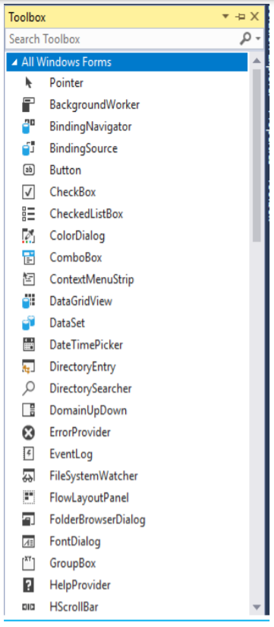

**METHODOLOGY**

A software development methodology engineering is a framework that is used to structure.Plan and control the process of developing an information system . A software development process also known as software development life cycle (SDLC), is a structure imposed on the development of a software product. The main idea of the SDLC has been pursue the development of information system in a very deliberate structure and methodical way. Requiring each stage of the life cycle from inception of the idea to delivery of the final system.

We can say a software development methodology is a framework that is used to structure,plan and control the process of developing an information system that are created and completed by a project team to develop or maintain an application.

**DATABASE DESIGN**

The general theme behind a database is to handle information as an integrated whole. A database is a collection of interreleated data stored with minimum redundancy to serve many users quickly and effectively .After designing input and output the analyst must concentrate on database design or how data should be organized around user recuirements.The general objective is to make information access,easy quick ,inexpensive and flexible for other users. During database design the following objectives are concerned

* Controlled Redundancy
* Data independence
* Accurate and integrating
* More information at low cost
* Recovery from failure
* Privacy and security
* Performance
* Ease of learning

**SOFTWARE REQUIREMENT SPECIFICATION**

**GENERAL DESCRIPTION**

**PRODUCT DESCRIPTION**

E-Plant solution is an e-commerse website which deals with selling of crop or plant seeds and fertilizers or pestisides etc. It also helps for knowing or learning about agricultures related informations.

**PROBLEM STATEMENT**

* Cost Consuming
* Space Consuming
* Difficult To search products

**SYSTEM OBJECTIVES**

* Improvement in control and performance

This system is developed to cope up with the current issues and problems of Website.

* Save time

Admin and User is able to search product by using few clicks of mouse and few search keyboard thus saving the valuable time.

* Admin

Admin have right to add or delete the user account

**FUNCTIONAL REQUIREMENTS**

**User Login**

Description of feature

This feature is used by the user to login into system. They are required to enter user id and password before they are allowed to enter the system .The user id and password will be verified and if invalid id is there user is allowed to not enter the system.

**Functional requirements**

* User id is provided when they register
* The system must only allow user with valid id and password to enter the system
* The system performs authorization process which decides what user level can access to
* The user be able to logout after they finished using system.

**REGISTER NEW USER**

**Description of feature**

This features can be performed by all users to register new user to create account.

**Functional requirements**

* System must be able to verify information
* System must be able to delete information if information is wrong

**INSERT NEW PRODUCT**

**Description of feature**

This features allows to add new product to the website.

**Functional requirements**

* System must be able to allow product id.

**VIEW BOOK**

**Description of feature**

* This features allows to view all products.

**Functional requirements**

* System must be able to Product id information in database.
* System must be able search if Product is available.

**DATA FLOW DIAGRAM**

**Admin**

product

users

Accsess

insert

**SOFTWARE INTERFACE**

**SCREENSHOT**

1. **User Login Panel / Create new account**

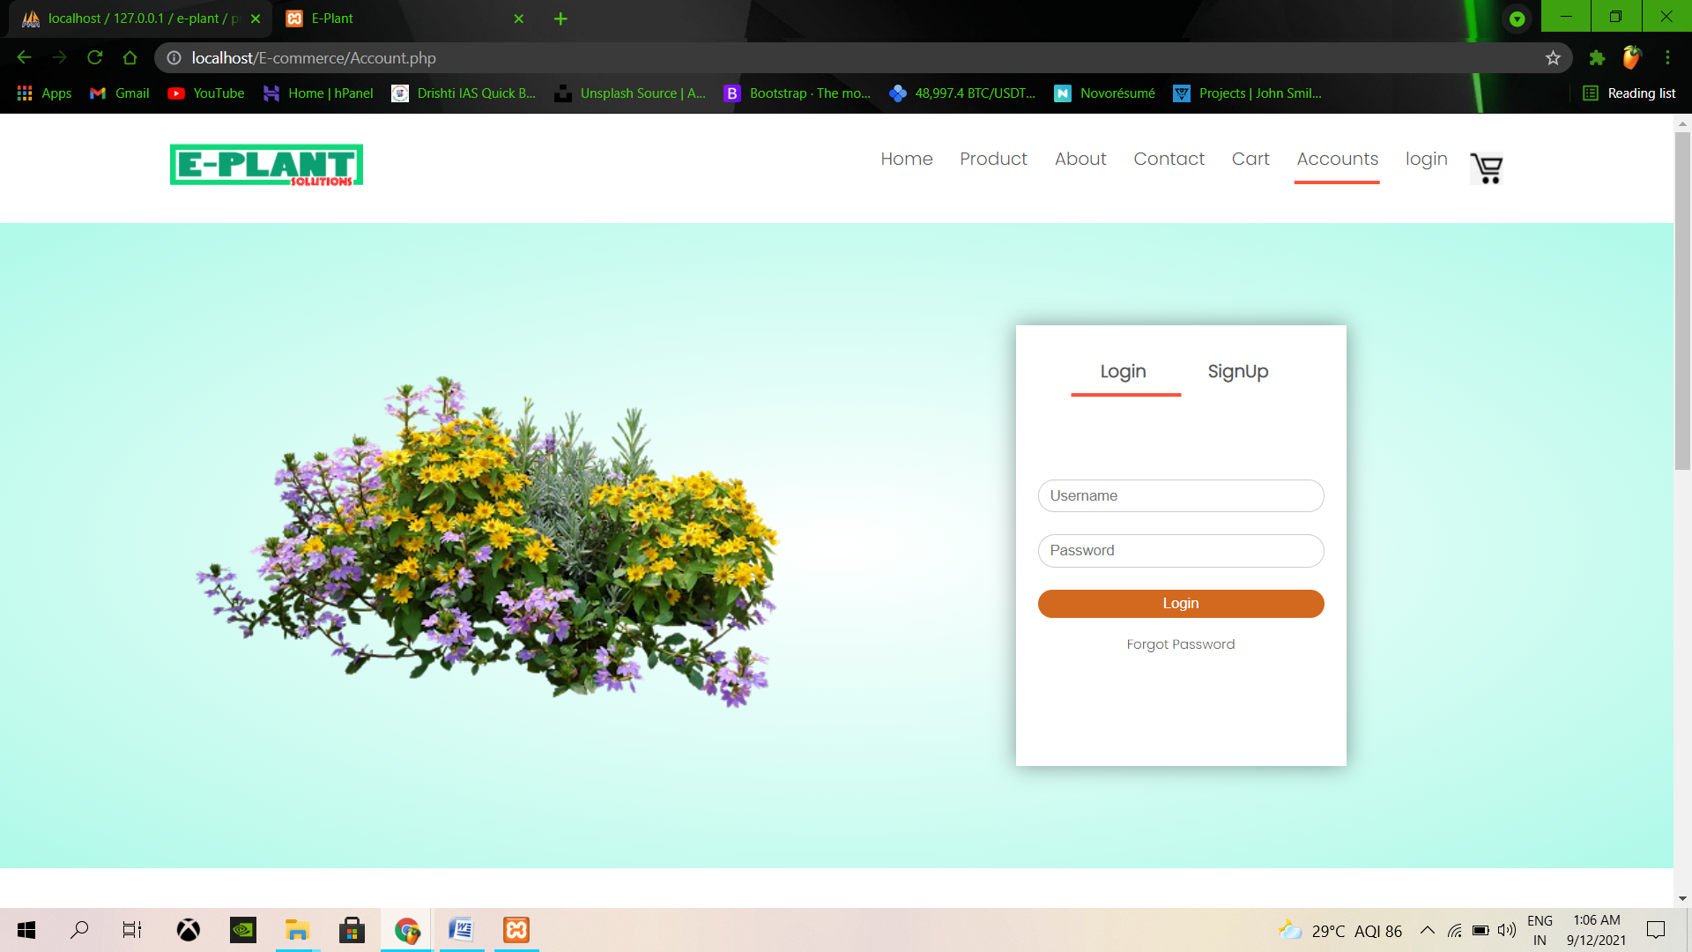

**Fig.1.1 User login panel**

**Fig.1.2 Create New Account**

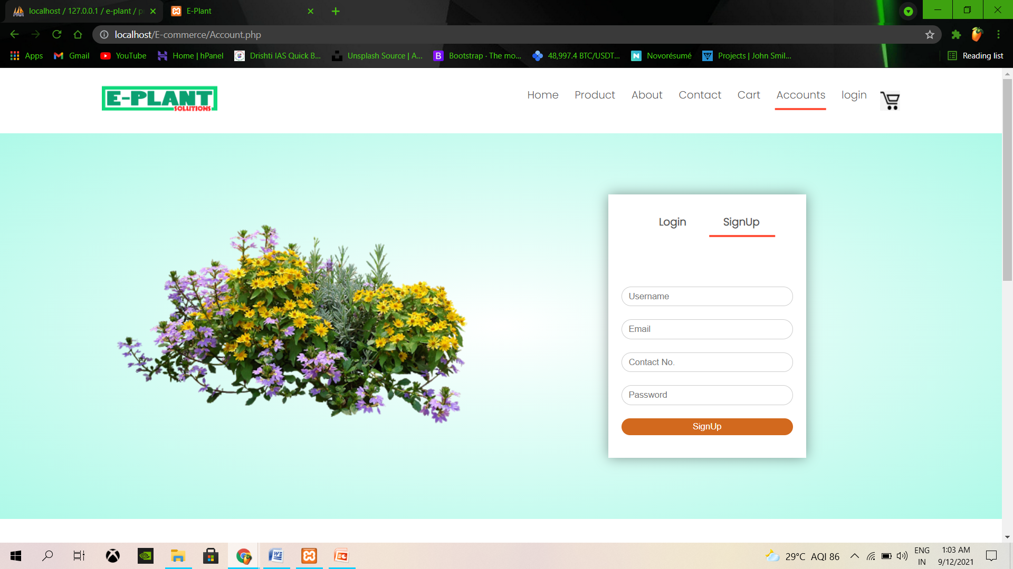

1. **Admin Section**

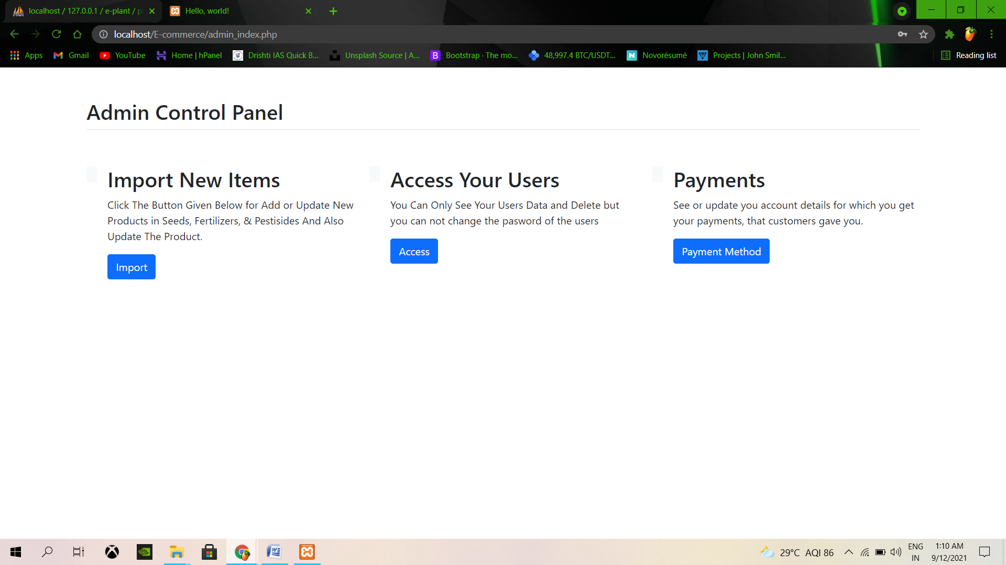

**Fig. 2.1 Admin Control Panel**

1. **Add New Product**

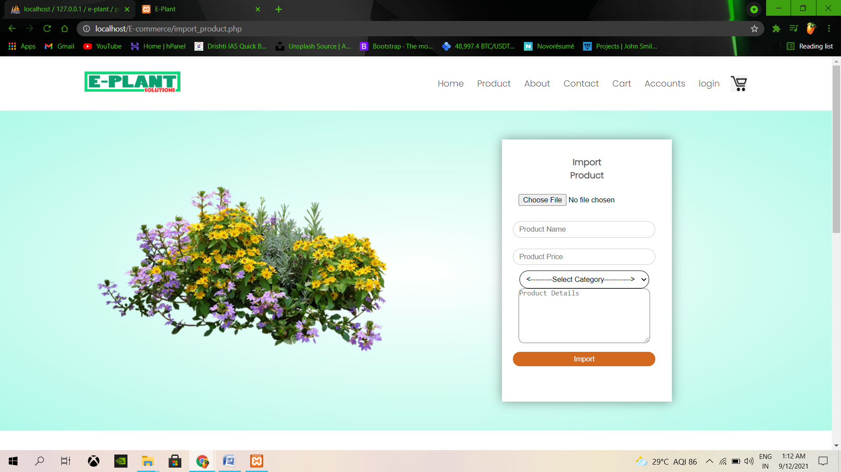

Fig.3.1 Insert New Product

**USER DETAILS PANEL**

1. **Database Design**

This refers to the tables used in the proposed system. The database design for the proposed system is as shown below

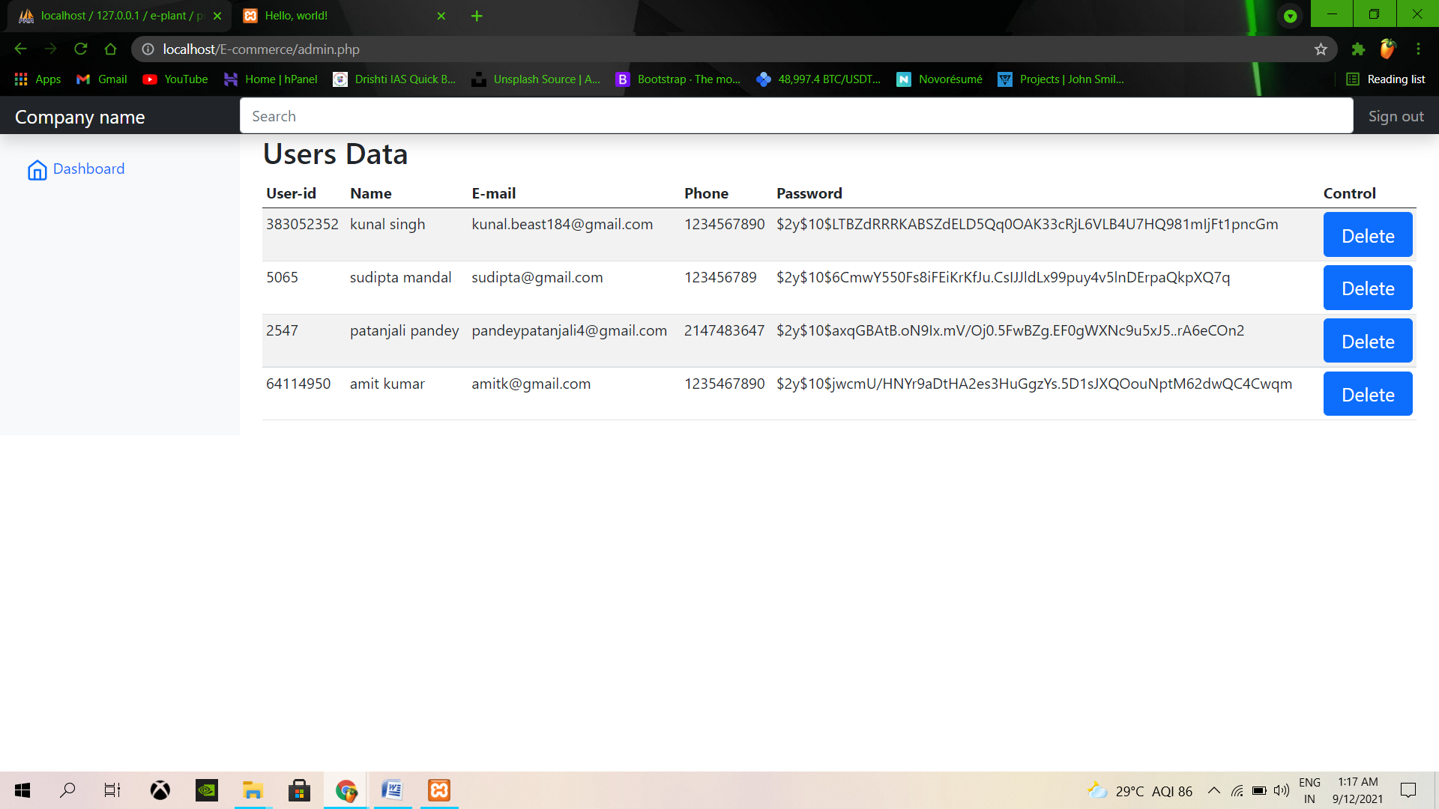

Fig.4.1 Screenshot for user details

1. **Show Product Panel**

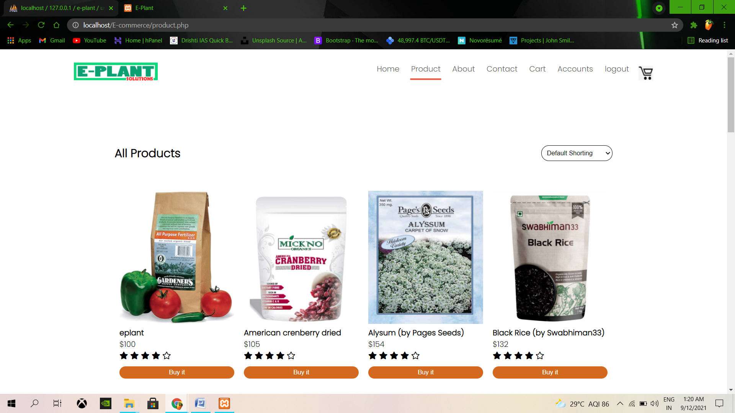

**Fig.5.1 Showing All Products**

1. **Show Product Details Panel**

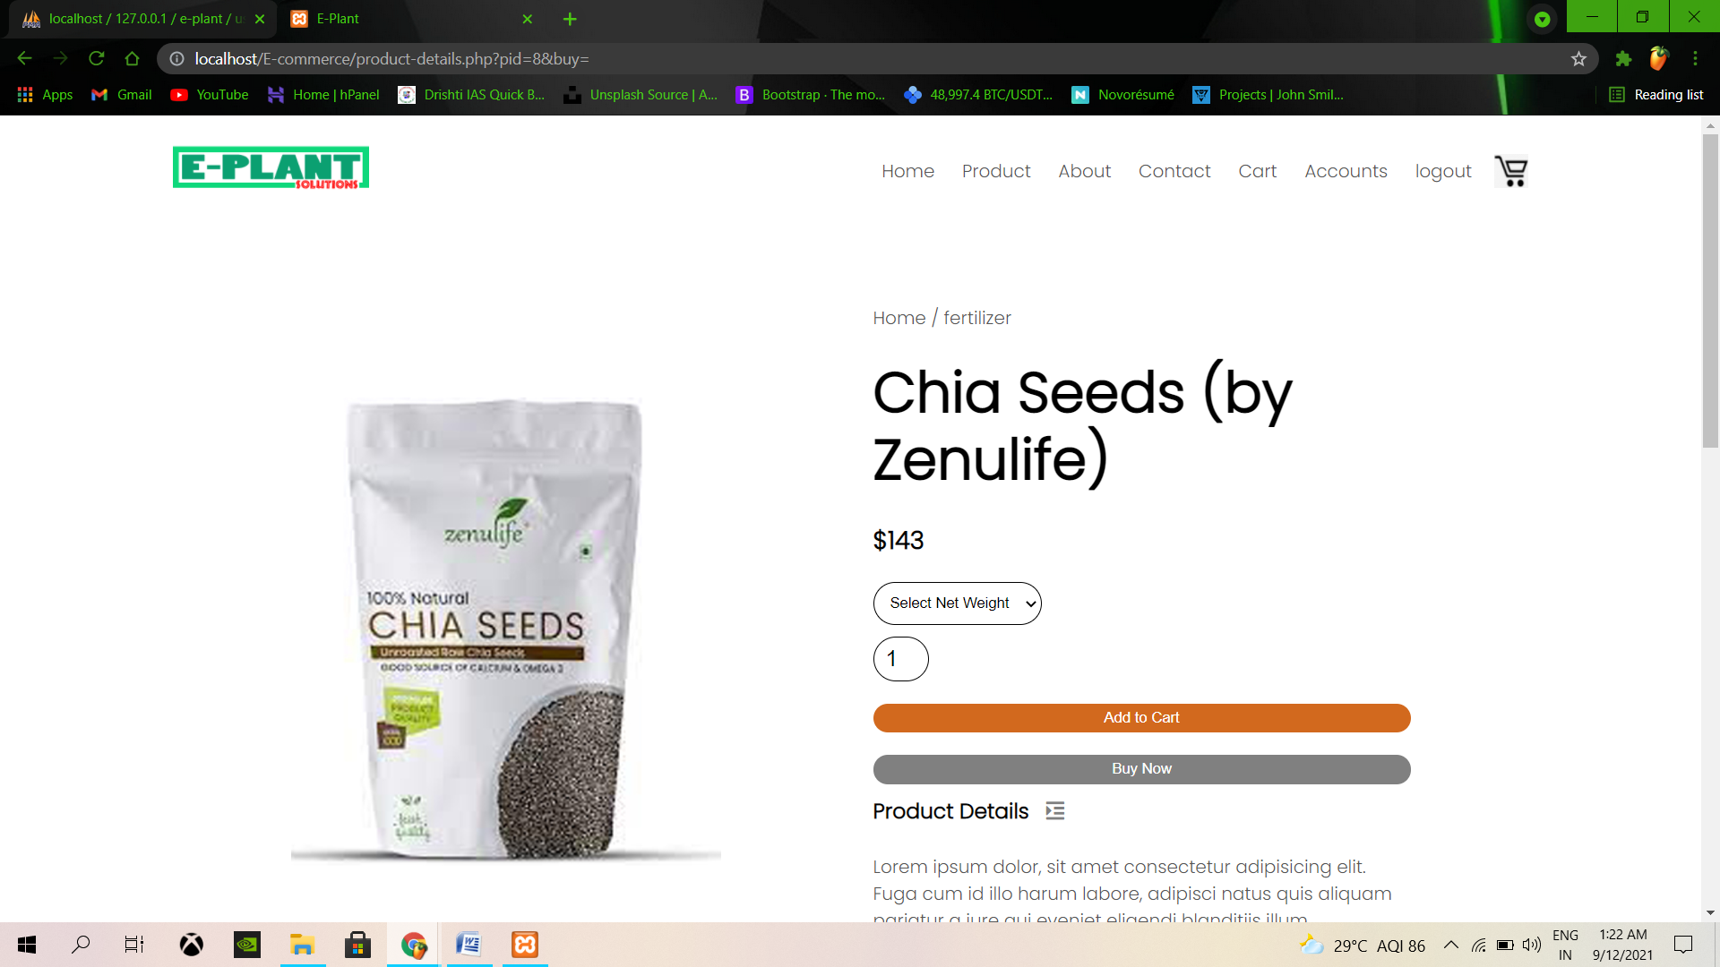

**Fig.6.1 Products Details Page**

1. **Cart Page**

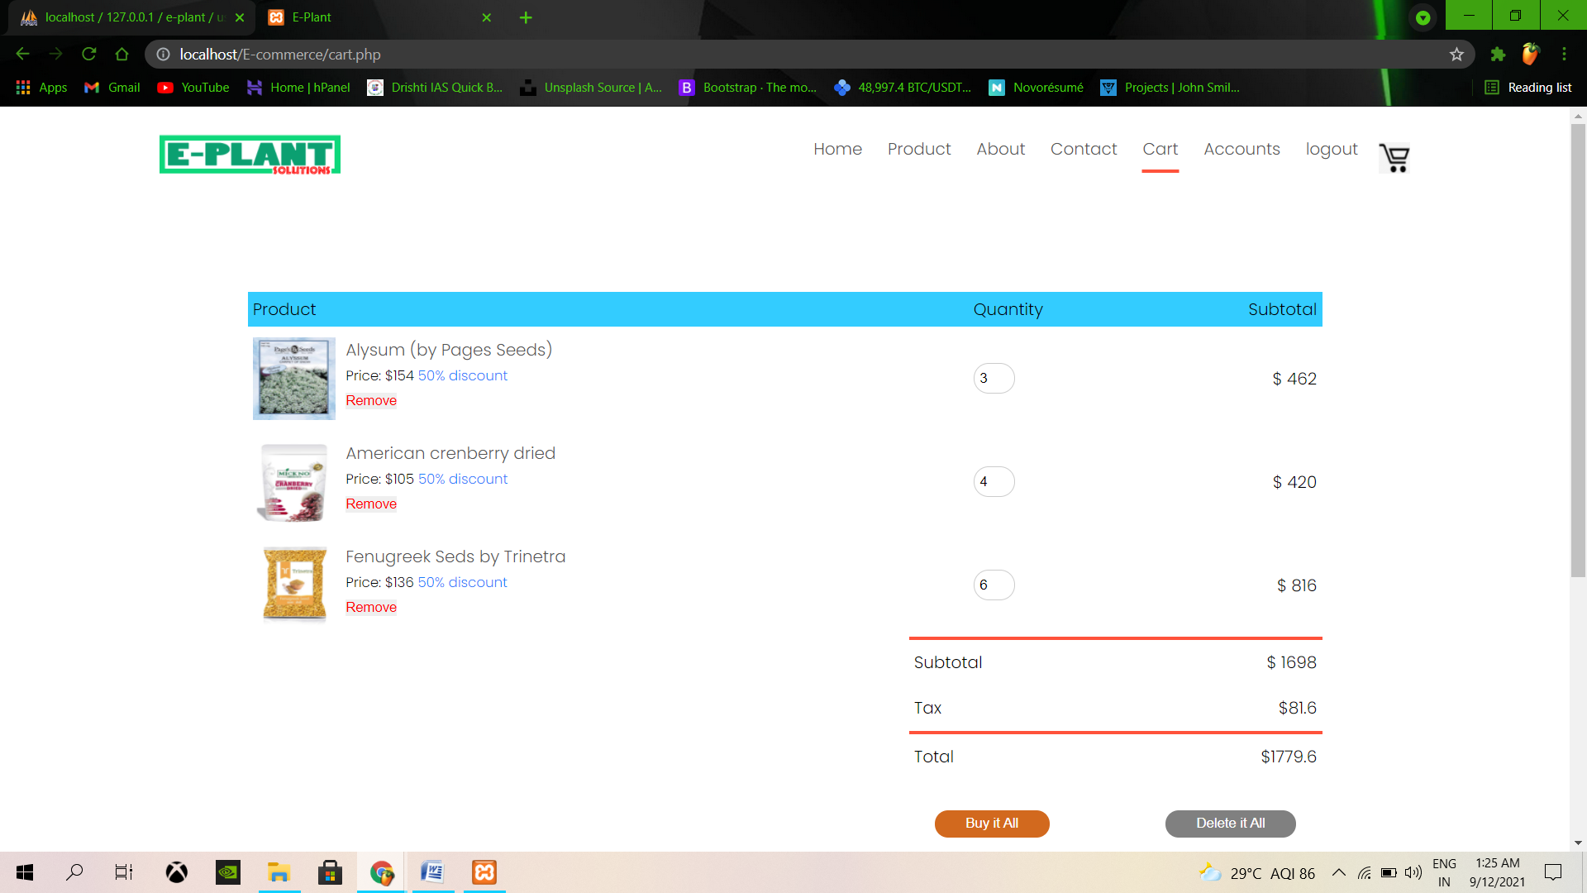

**Fig.7.1 Cart Page**

1. **Checkout Page**

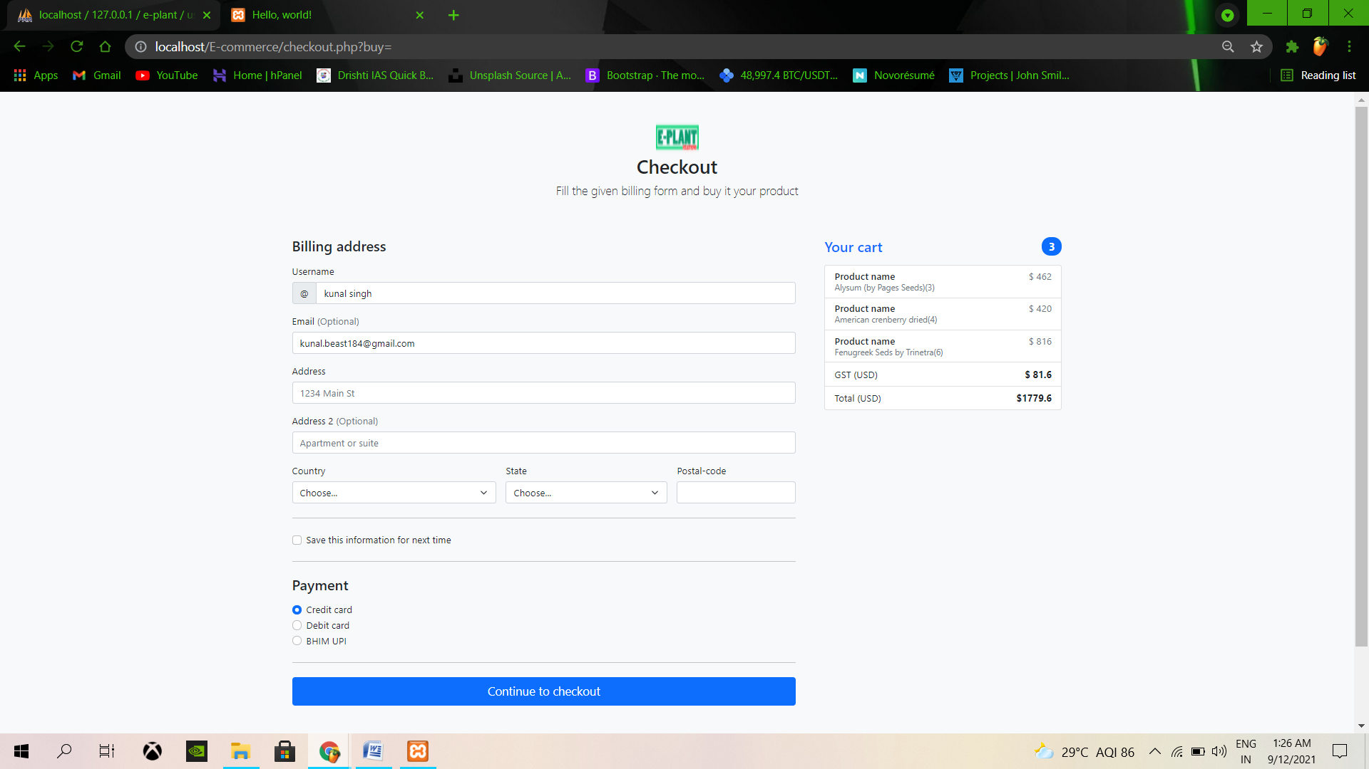

**Fig.8.1 Checkout Page**

1. **View Product Id**

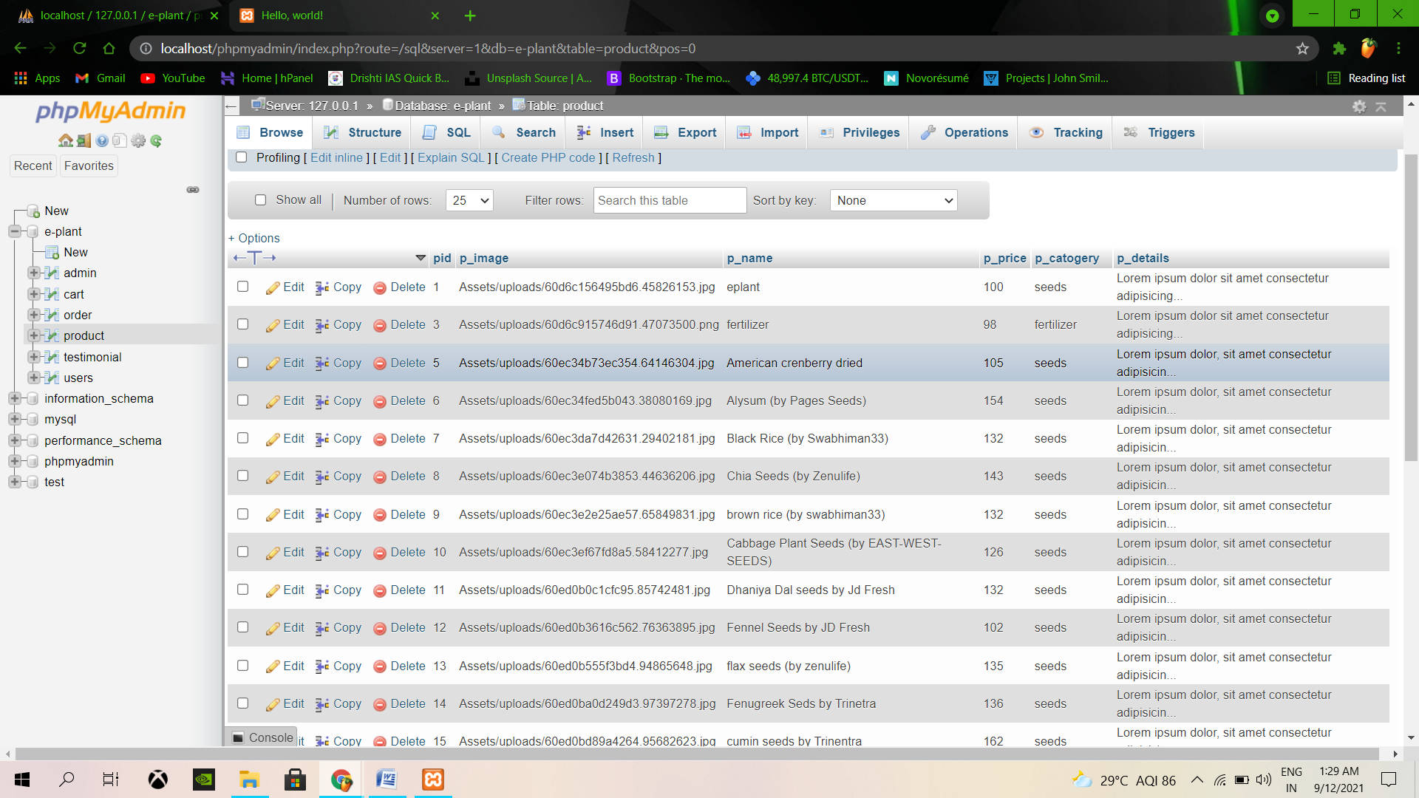

**Fig.9.1 Showing Product id**

**SOURCE CODE SECTION**

1. **Database Connection**

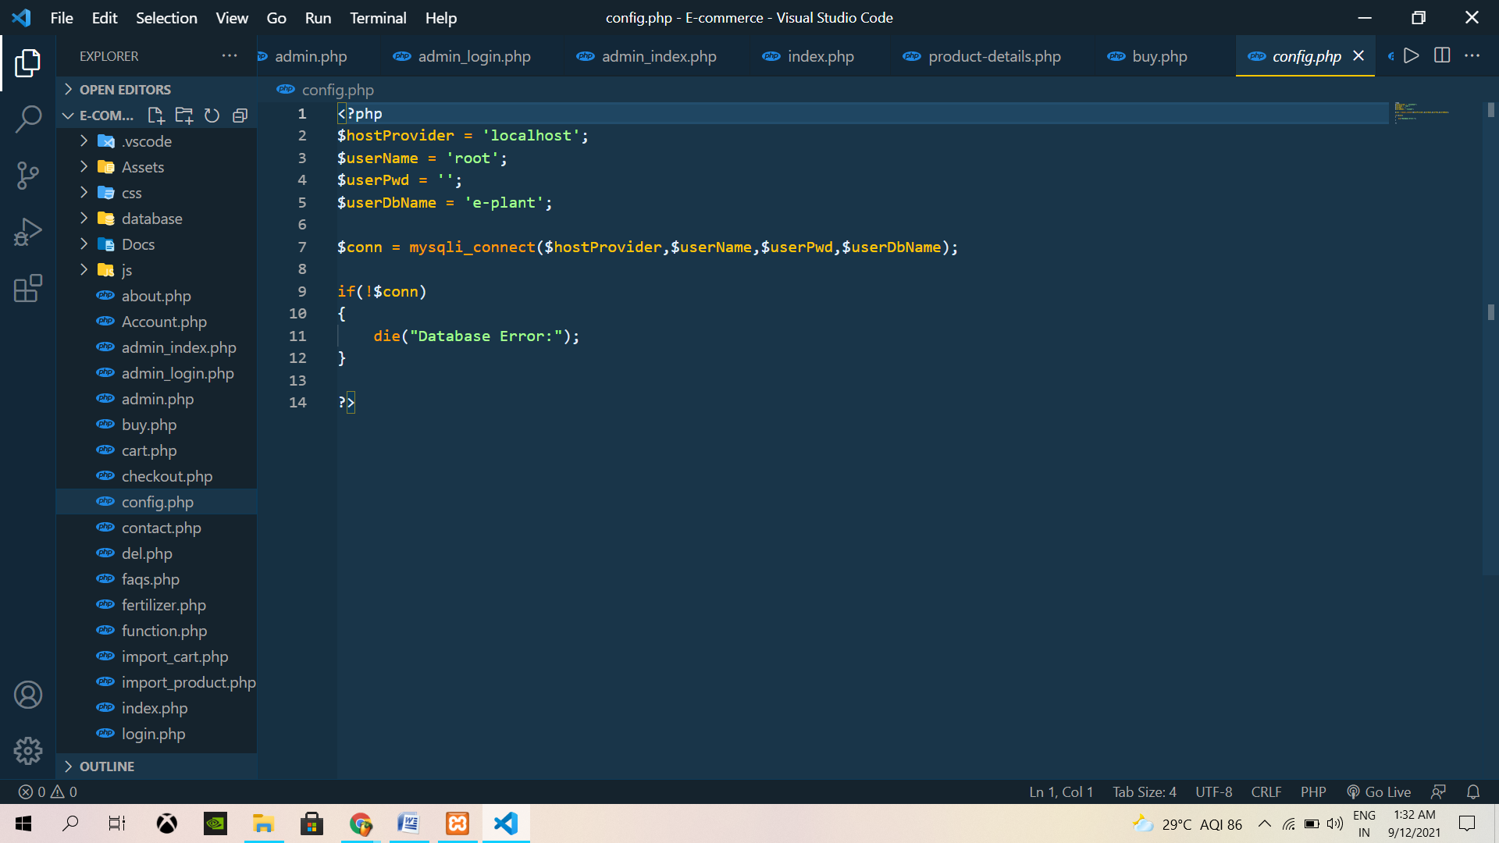

1. **Login Page**

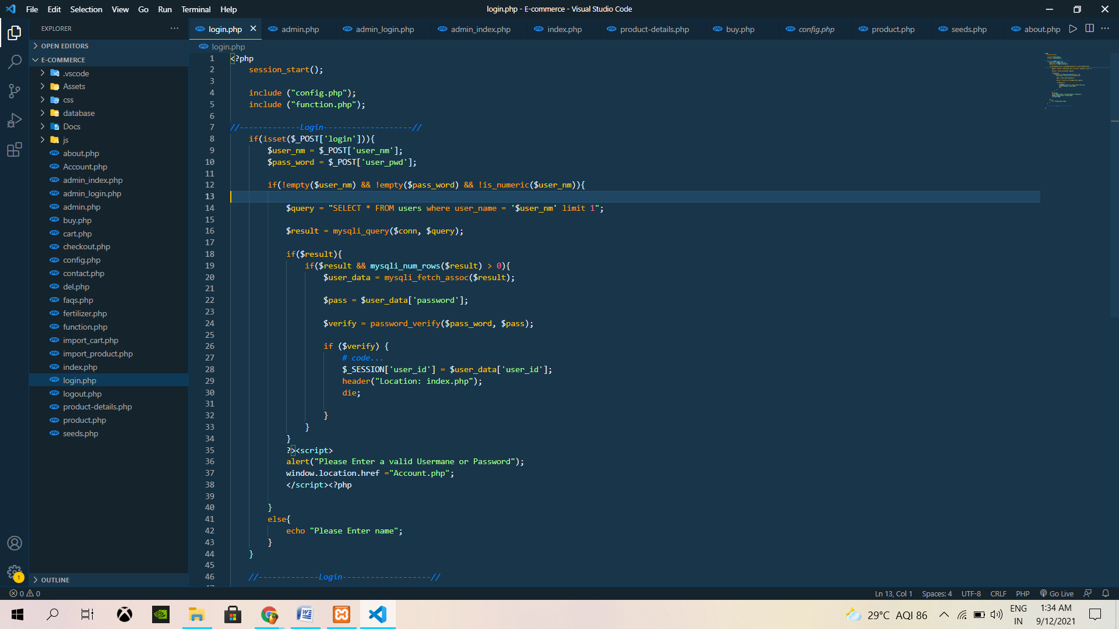

1. **Insert New Product**

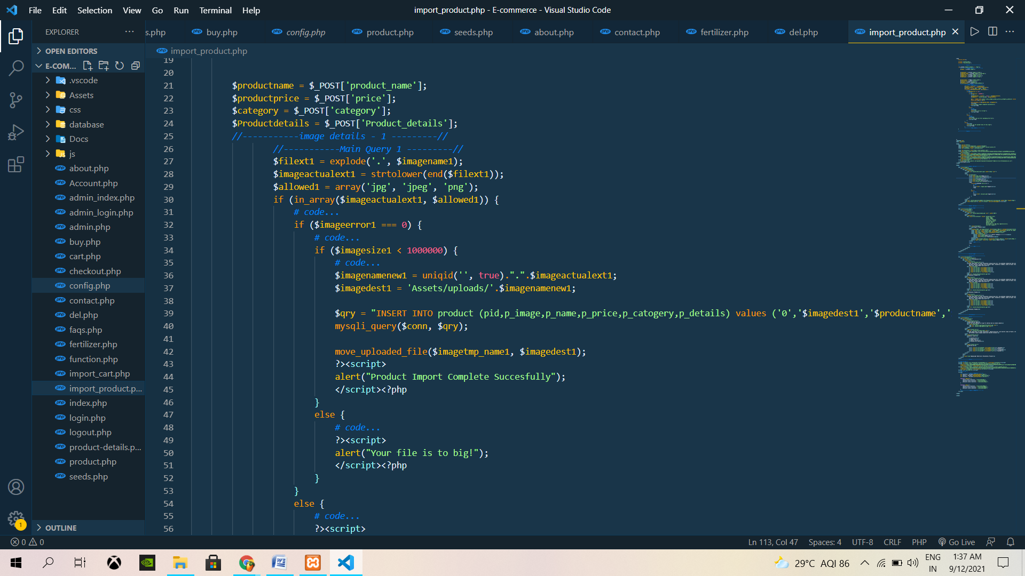

1. **Create New Account Form**

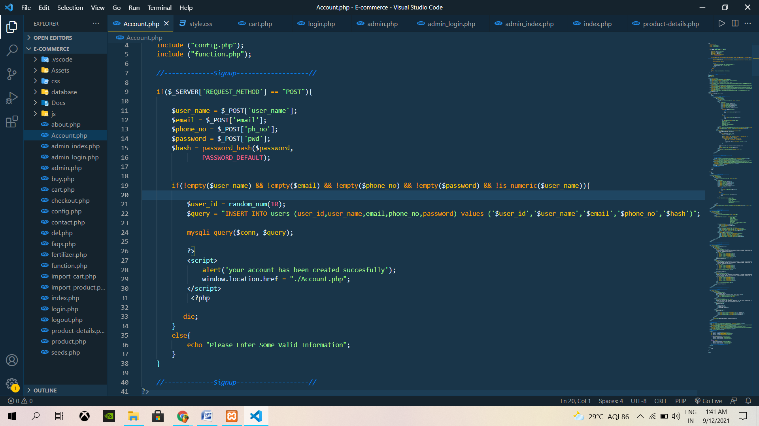

1. **Product Details View Form**

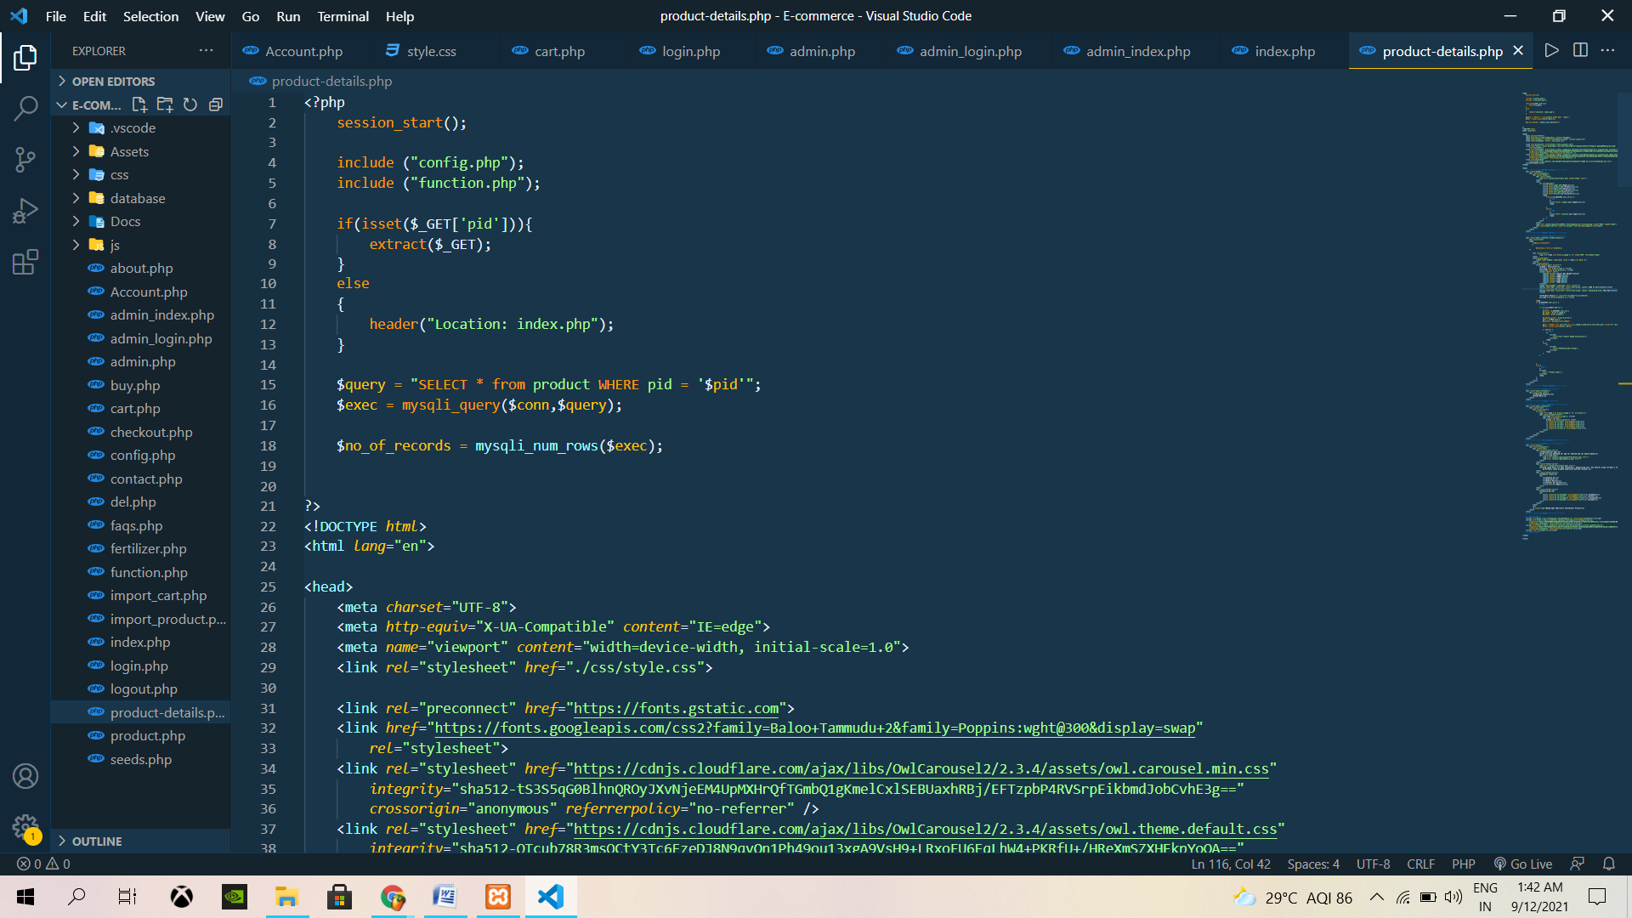

1. **Checkout Page Form**

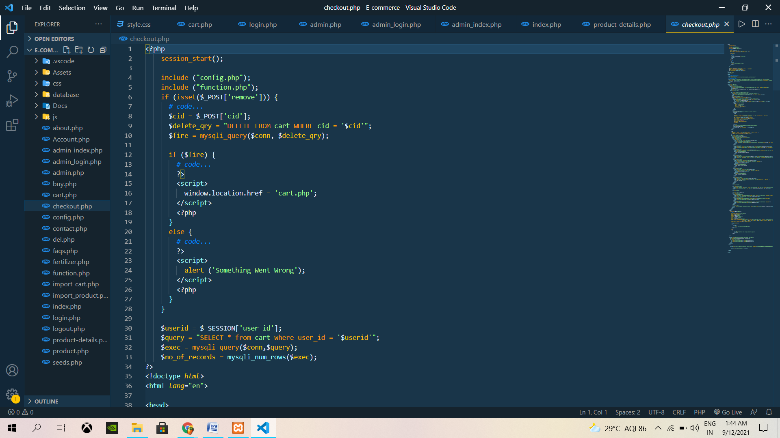

**SYSTEM TESTING**

The aim of the system testing process was to determine all defects on our project .The program was subjected to a set of test inputs and various observation were made and based on these observation it will be decided whether the program behaves as expected or not.

Our project went through many levels of testing some example

* Unit testing
* Integration testing

**UNIT TESTING**

Unit testing is under taken when a module has been created and successfully reviewed.In order to test a single module we need to provide a complete environment ie besides the moudule would require.

* The procedure belonging to other modules that the module under test calls
* Non local data structures that module accesses
* A procedure to call the functions of the module under test with appropriate parameters

Unit testing was done on each and every module.

**Test for admin module**

* Testing admin login form- This form is used for log in administrator of the system. In this we enter the user name and password.
* User account addition
* Product addition – Admin can enter details of product add new product

**Test for Student Login Module**

* Test for User login form –This form is used for log in of user. In this we enter the username and password if all these
* Are correct User login page will open otherwise if any of data is wrong it will get redirect back to the login page and again ask for user name and password.
* Test for account creation –This form is used for new account creation when user does not fill the form completely it asks again to fill the whole form when he fill the form fully it gets redirected to page which show waiting for confirmation message.

**INTEGRATION TESTING**

In this testing we test various integration of the project module by providing the input .The primary objective is to test the module interfaces in order to ensure that no errors are occurring when one module invokes the other module.

**SUMMARY**